Solutions for Homework3 - CPRE530
Submitted by:

Homework Problems:
1-a)
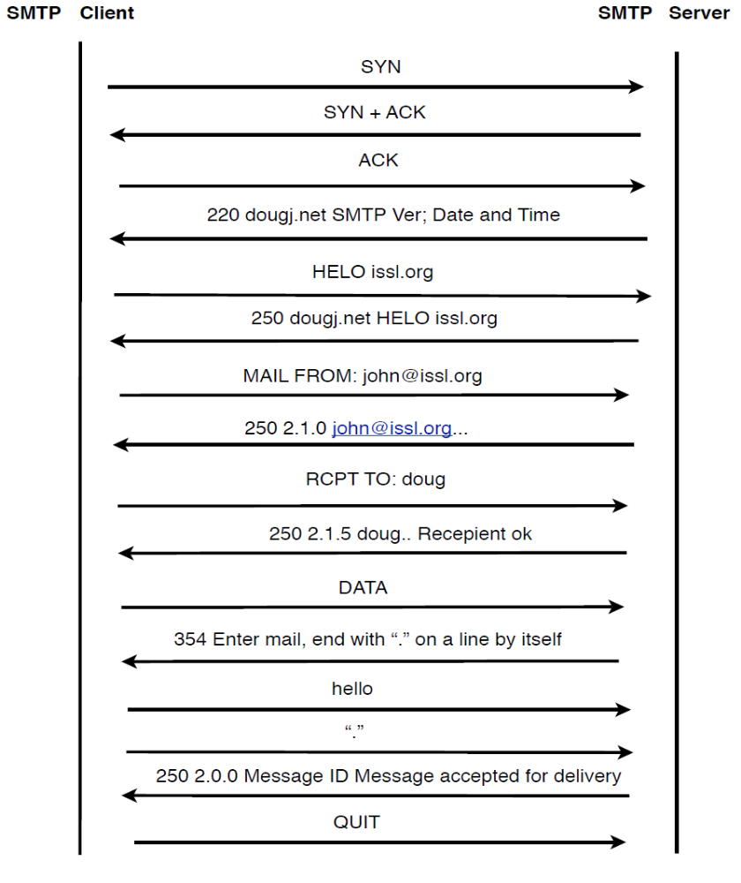

b) The TCP payload required to establish a TCP connection and send the message is
55 bytes.

c) The total number of bytes including the IP and Ethernet header are - 936 bytes. IP
header of 30 bytes and ethernet header of 25 bytes per TCP packet.

d) The total overhead, that is the number of bytes sent on the wire vs the total size of
the payload is 936 bytes Vs 55 bytes.

e) The total overhead, that is the total number of bytes sent on the wire vs the user
message is - 936 bytes Vs 5 bytes.

12)
Every MTA that passes the email, attaches its own header to it. The header would contain information such as the machine name and/or IP address of every MTA along the way. As long as the IP address is a public IP, we can trace. By tracing back to the MTA and with the knowledge of the IP address of the sender, we can get the physical location of the IP address of the sender from network registration authorities. However, if the sender IP address is a private IP address, tracing back to the physical location would not be possible.
To find out someone who is using email for illegal purposes would not be really useful because the attacker should be smart enough to use a public machine to carry out the illegal activity. If it is a public computer, it would be impossible to carry out the trace to the person. However, we could trace back to the owner of the IP address as long as it is not a private address.

13)
7 SPAM email headers were traced and all of them originated from the USA.

____________________

LAB EXPERIMENTS:

1) Sending an email to knram@spock.ee.iastate.edu
> telnet spock.ee.iastate.edu 25
Trying 129.186.215.48...
Connected to spock.ee.iastate.edu.
Escape character is '^]'.
220 spock.ee.iastate.edu ESMTP Sendmail 8.13.4/8.13.4; Fri, 7 Nov 2008 15:46:54
-0600 (CST)
HELO bone.ee.iastate.edu
250 spock.ee.iastate.edu Hello bones.ee.iastate.edu [129.186.215.41], pleased to meet
you
MAIL FROM: knram@bones.ee.iastate.edu
250 2.1.0 knram@bones.ee.iastate.edu... Sender ok
rcply to: knram
250 2.1.5 knram... Recipient ok
data
354 Enter mail, end with "." on a line by itself
Hi there
.
250 2.0.0 mA7LksIL096730 Message accepted for delivery

2) Commands to Retrieve Mail from spock.ee.iastate.edu
> telnet spock.ee.iastate.edu 110
Trying 129.186.215.48...
Connected to spock.ee.iastate.edu.
Escape character is '^]'.
+ O K Q P O P ( v e r s i o n 2 . 5 3 ) a t s p o c k . e e . i a s t a t e . e d u s t a r t i n g .
<76848.1226096425@spock.ee.iastate.edu>
user knram
+OK Password required for knram.
pass cpre530
+OK knram has 1 message (520 octets).
list
+OK 1 messages (520 octets)
1 520
.
retr 1
+OK 520 octets
Return-Path: knram@bones.ee.iastate.edu
Received: from bone.ee.iastate.edu (bones.ee.iastate.edu [129.186.215.41])
by spock.ee.iastate.edu (8.13.4/8.13.4) with SMTP id mA7LksIL096730
for knram; Fri, 7 Nov 2008 15:47:34 -0600 (CST)
(envelope-from knram@bones.ee.iastate.edu)
Date: Fri, 7 Nov 2008 15:46:54 -0600 (CST)
From: knram@bones.ee.iastate.edu
Message-Id: <200811072147.mA7LksIL096730@spock.ee.iastate.edu>
To: undisclosed-recipients:;
X-UIDL: 66bdfd8413c8100bd537c5ba22b05a26
Hi there
.

3) Tracing back emails-
Email Message From Source Traced To
rkarthik@gmail.com 72.33 .87.233 – Dallas, Texas
anil12@gmail.com 214.233.20.59 – Chennai, India
sriram@hotmail.com 81.32.65.43 – Seattle, Washington
systemsuport@tcs.com 202.138.127.106 - Hyderabad, India

